Milli-Spinner (of Stanford University’s Zhao Lab)
Novel Mechanical Thrombectomy Device – publicly announced June 2025

Executive Overview Background Information Key Personnel Technology Targeted Indications & Markets Preclinical & Regulatory Pathway Intellectual Property Investors & Additional Resources Conclusion
1 1 2 3 5 6 7 9 10
TABLE OF CONTENTS
Executive Overview:
- The Milli-Spinner is a millimeter-scale device featuring a hollow tube with magnetically driven rotating fins and slits, which generate a spinning-induced flow field to efficiently deliver targeted axial force for clot disruption
- The team has demonstrated a catheter-deliverable and untethered version of the device
- Unlike traditional aspiration and stentriever tools - which rely on snaring or suction - the Milli-Spinner applies compression and shear forces, compacting clots into dense, tiny balls of fibrin before removal, minimizing risk of other complications during/after a procedure
- Through localized suction and rapid spinning, the device is able to shrink clot volume (by up to 95% in preclinical tests) in vessels, without breaking through tough fibrin threads
- This device is a completely novel approach in the field of mechanical thrombectomy
- Dr. Renee Zhao and Dr. Jeremy Heit have started a new company that licenses the technology from Stanford in order to develop and bring it to market
Source: Zhao Lab’s YT Page: https://www.youtube.com/watch?v=FBA4I3fIBMU
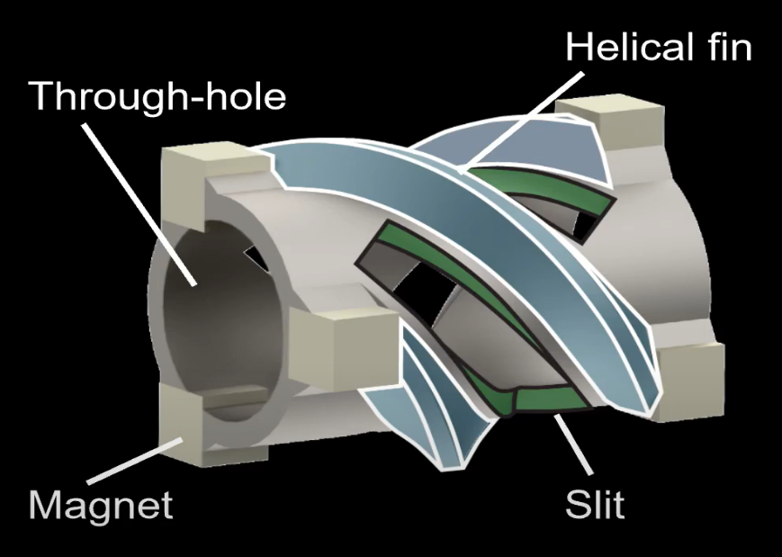
[Figure 1] The Device

OD = 1-3.5 mm

L = 1-6 mm

Background Information:
Dr. Ruike Renee Zhao, assistant professor of mechanical engineering, and Dr. Jeremy J. Heit, associate professor of radiology and neurosurgery, both at Stanford University, began to explore how a device designed by Zhao could mechanically dissolve blood clots to treat stroke patients. The proposed device would be delivered via a guiding catheter inserted into the femoral artery, as is standard in current mechanical thrombectomy procedures. It would then navigate through the peripheral, cardiac, and neurovascular systems to reach the targeted clot. Upon contact, the device - shown in [Figure 1] - is magnetically spun to compress the clot before it is suctioned out. Dr. Zhao believed this method may be more effective than current aspiration-based clot removal techniques and the pair began collaborating to develop a working device around 2023 or 2024.
The technology needed to effectively rotate the device and generate sufficient force took years to master. However, neither Dr. Zhao nor Dr. Heit had any experience in medical device commercialization. In an interview published by Stanford Dr. Heit reflected, “We’re a physician and a scientist. We like to ask questions … but, if you’re going to take a scientific discovery and get it into patients … there is a huge knowledge gap.” The challenge of bridging university research and industry commercialization efforts is common in medical device development.
Recognizing they had an innovative novel asset but little understanding of how to bring it to market, the pair reached out to Stanford’s Center for Biodesign for guidance. They were connected with Dr. Paul Yock, one of the program’s founding directors. Dr. Yock has played a prominent role in developing Stanford’s Biodesign program into a globally recognized hub for medical device innovations. Since the program’s inception in 2001, Stanford Biodesign has spun out more than fifty-seven health technology companies based on the inventions of Biodesign fellows and trainees.
The first academic research article on the technology (authored by Dr. Zhao, Dr. Heit and 5 co-authors), titled “Magnetic Milli-spinner for Robotic Endovascular Surgery,” was published by the team in October of 2024. In this article (personally accessed on ResearchGate) the team presented their findings and interest in further developing the Milli-Spinner, which had promising applicability in the medical device field.

Key Personnel:
Renee Zhao, PhD - Assistant Professor of Mechanical Engineering and, by courtesy, of Bioengineering
Dr. Ruike Renee Zhao is an Assistant Professor of Mechanical Engineering at Stanford University, where she leads the Soft Intelligent Materials Laboratory. Dr. Renee’s research focuses on developing stimuli-responsive soft composites for multifunctional robotic systems with integrated shape-changing, assembly, sensing, and navigation capabilities.


Email: rrzhao@stanford.edu
Jeremy J. Heit, MD, PhD - Associate Professor of Radiology (Neuroimaging, Neurointervention) and, by courtesy, of Neurosurgery
Dr. Jeremy Heit is an Associate Professor of Radiology and of Neurosurgery and the Chief of Neuroimaging and Neurointervention at Stanford University. Dr. Heit is a neurointerventional surgeon (neurointerventional radiologist) who specializes in neurovascular and spinal endovascular interventional procedures. He treats these conditions using minimally invasive, image-guided procedures and state-of-the-art technology.

Email: jheit@stanford.edu
Tel: (650) 723-6469

Dr. Paul Yock - Martha Meier Weiland Professor in the School of Medicine and Professor of Bioengineering, Emeritus
Prof. Paul Yock began his faculty career as an interventional cardiologist at UC San Francisco and then moved to Stanford in 1994. Prof. Yock is known for his work in inventing, developing, and testing new medical devices. Prof. Yock was the founding Co-Chair of the Department of Bioengineering and continues research related to new device technologies. He also was the founding director of the Stanford Byers (now Mussallem) Center for Biodesign - dedicated to advanced training in medical technology innovation.

Email: yock@stanford.edu
Tel: (650) 736-1161
Technology:
In recent articles published in Nature (June 4, 2025 & July 1, 2025), more details were revealed on how the Milli-Spinner device operates and indications that the team is aiming to address. Early into the development of the device, Zhao noted that blood clots are held together by fibrin - a tough, thread-like protein that traps red blood cells and other materials to form a sticky clump. According to the NIH, “current mechanical thrombectomy methods fail to remove clots in 10-30% of patients, especially in cases involving these large, fibrin-rich clots.” These clots result in patients experiencing a variety of adverse conditions throughout the body, risking fatal complications.
The Milli-Spinner uses simple yet creative mechanical concepts to modify a clot’s microstructure, facilitating a clot’s removal more effectively than current aspiration and stentriever technologies. It works by mechanically densifying the clot’s fibrin network and releasing red blood cells through spinning-induced compression and shear forces, reducing clot volume. In lab demonstrations, Zhao’s team has reported that the device is able to shrink the clot volume by 95% for safe and quick removals. These findings were later documented in a PubMed article titled “Milli-Spinner Thrombectomy.” The team began publicly uploading in vitro technology demonstrations to the Lab’s YouTube channel (Zhao Lab) in early June of 2025 and recently published an in vivo experiment in swine models to demonstrate the device’s effectiveness in animal tests.
The device’s spinning force is generated by precise magnetic fields (provided by Helmholtz coils) that enable the centrifuge and its fins to float freely, and spin suspended within a vessel. This magnetic drive eliminates the need for physical shafts or bearings, allowing frictionless, smooth rotation and precise control of spin dynamics. Contactless magnetic propulsion is a key innovation around the novel approach, enabling the device’s unique ability to densify and shrink blood clots effectively while maintaining delicate control during thrombectomy procedures. Zhao and her colleagues are also working on an untethered version of the Milli-Spinner by leveraging the device’s magnetic properties, which could then swim freely through blood vessels to target and treat clots.
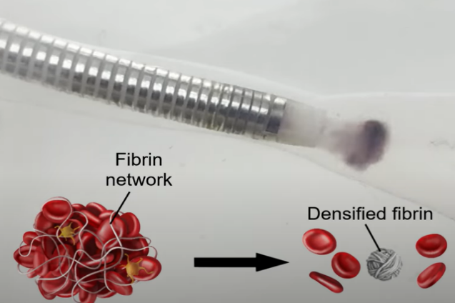
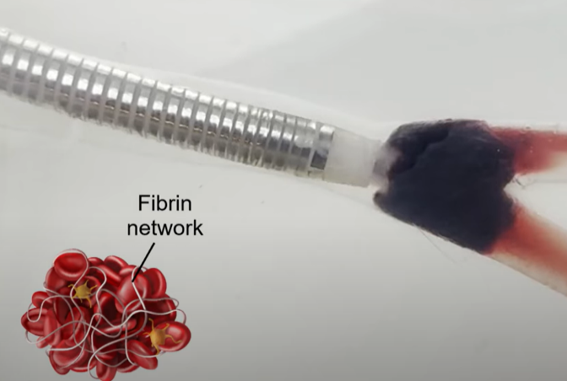
[Figure 2] Early prototype of Milli-Spinner w Catheter
[Figure 4]
[Figure 3]
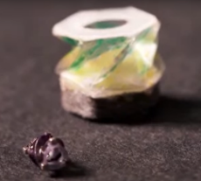

Source: Zhao Lab’s YT Page: https://www.youtube.com/watch?v=OxRUC0gu-AA

“With existing technologies, there’s no way to reduce the size of the clot. They [neurointerventional radiologists] rely on deforming and rupturing the clot to remove it,” said Zhao in a Stanford report. She continued, “what’s unique about the Milli-Spinner is that it applies compression and shear forces to shrink the entire clot, dramatically reducing volume without causing ruptures [to fibrin structure]. Imagine a loose ball of cotton fibers. If you press it between your palms (compression) and rub your hands together (shear), the fibers become increasingly tangled into a smaller, denser ball. The Milli-Spinner is able to do the same thing with the fibrin threads in a clot, using suction to compress the clot against the end of the tube … rapidly spinning to create the necessary shear.”
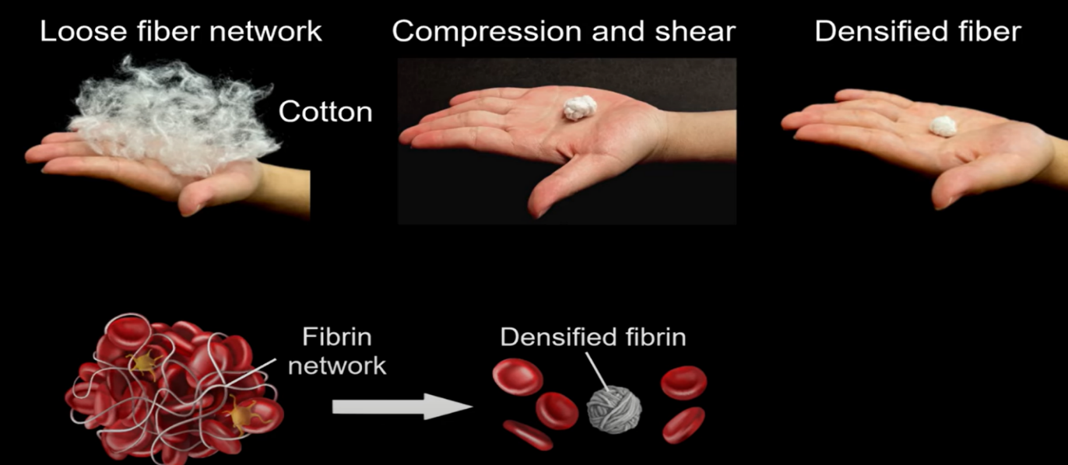
Source: Zhao Lab’s YT Page: https://www.youtube.com/watch?v=OxRUC0gu-AA
[Figure 5]

Jeremy Heit added further insight: “For most cases, we’re more than doubling the efficacy of current technologies, and for the toughest clots … we’re getting the artery open on the first try 90% of the time.” He closed with, “It’s unbelievable. This is a sea-change technology that will drastically improve our ability to help people.” The Milli-Spinner can be scaled up or down based on the vessel size and application. Current information states the device has an outer diameter of 1.2-3.5mm and a length of 1-6mm depending on configuration.
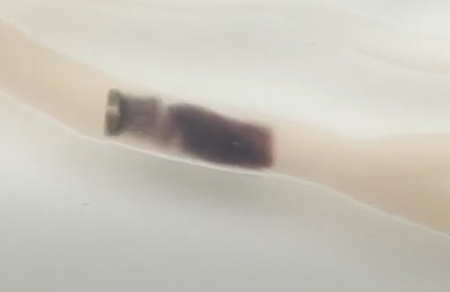
The team has also provided demonstrations of the untethered prototype device through uploads on the Zhao Lab YouTube channel.
[Figure 6] Milli-Spinner navigating untethered through a neurovascular model
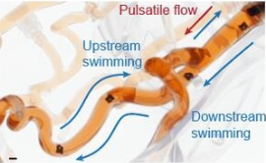
[Figure 7] Free floating Milli-Spinner on Thrombus
Source: https://www.researchgate.net/publication/385317421_Magnetic_Milli-spinner_for_Robotic_Endovascular_Surgery
Milli-Spinner
Free floating Milli-Spinner

Source: https://www.youtube.com/watch?v=FBA4I3fIBMU

Thrombus

Targeted Indications & Markets:
Milli-Spinner has the potential to address a broader range of thrombus and emboli related complications when compared to currently available treatments. This device represents a promising advancement in clot removal by fundamentally transforming the clot’s microstructure, enabling faster, more complete, and less damaging thrombectomy procedures. Dr. Zhao and Dr. Heit are actively testing the Milli-Spinner for use across a spectrum of vascular indications throughout the body. Conditions that may be addressable with Milli-Spinner include:
Targeted Indication | Description | Cases per Year (U.S.)
Acute Coronary Syndrome (ACS) | Sudden, reduced blood flow to the heart, leading to chest pain & risk of Myocardial Infarction | ~1.2 million Patients
Coronary Artery Thrombosis Causing Myocardial Infarction (MI) | Major contributor to ACS; a clot forms (thrombus), blocking a coronary artery, causing an infarction | ~720k  Patients
Ischemic Stroke | Blockage of cerebral blood vessels by a clot, leading to loss of brain function | ~700k  Patients
Carotid Artery Thrombosis Causing Transient Ischemic Attacks (TIAs) | Clot formation in carotid arteries temporarily blocking blood flow to the brain ("mini strokes") | ~240k  Patients
Thrombosis in Grafts or Stents (Vascular or Cardiac) | Formation of clots within vascular grafts or stents that can obstruct blood flow | ~2% of Stent Recipients
Acute Limb Ischemia (ALI) | Atherosclerotic buildup in the artery, leading to  the diseased vessel to narrow | ~250k  Patients
Pulmonary Embolism (PE) | A loose clot (emboli) that becomes lodged within the lungs, causing a larger clot to form | ~350k  Patients
Arterial Embolism | ACS contributor; sudden blockage of an artery by emboli, resulting in tissue ischemia downstream | ~500k  Patients
Deep Vein Thrombosis (DVT) | Blood clot formation in deep veins, usually in the legs, causing swelling, pain & risk of emboli | ~2 million  Patients
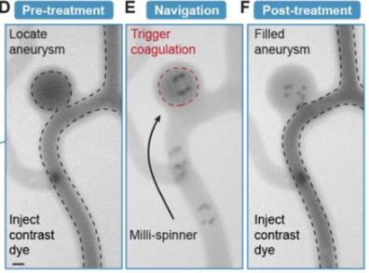
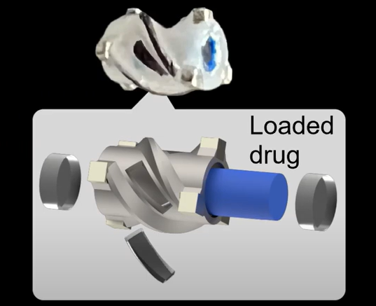
The team is also evaluating other use cases for the device. “We’re exploring other biomedical applications for the Milli-Spinner design, and even possibilities beyond medicine,” Zhao said. “There are some very exciting opportunities ahead.” Zhao mentioned specific interest in testing the technology to break up atherosclerotic buildup throughout the body and capture kidney stones during ureteroscopy procedures. There are also articles available on the Stanford Zhao Lab website demonstrating the Milli-Spinner as a potential targeted drug delivery system for anticoagulant medication, as well as concepts for the device to treat aneurysms (see [Figure 9]).
Source: Zhao Lab’s YT Page: https://www.youtube.com/watch?v=FBA4I3fIBMU
[Figure 9] Aneurysm Spin-Release Configuration - Milli-Spinner Demo
[Figure 8] Drug Eluting Configuration - Milli-Spinner Concept
Source: https://www.researchgate.net/publication/385317421_Magnetic_Milli-spinner_for_Robotic_Endovascular_Surgery

Preclinical & Regulatory Pathway:
In an article published in the Stanford Report (June 4, 2025) Zhao is quoted saying, “We’re working to bring this into clinical settings, where it could significantly boost the success rate of thrombectomy procedures and save patients’ lives.” The team behind Milli-Spinner initially began in vitro testing of the device inside of human pulmonary and cerebral artery models. In an article - “Magnetic Milli-spinner for Robotic Endovascular Surgery” - (mentioned earlier) Zhao and her colleagues proved in the experiment that at 8.4k rpm, the untethered Milli-Spinner could achieve a swimming speed of 14.5 cm·s^-1 within a model, which is sufficient to swim against a pulsatile flow with a peak flow velocity of 30 cm·s^-1. They also documented successful “ultrafast swimming abilities of the Milli-Spinner, with the swimming speeds of the device increases linearly with the spinning frequency.” The device was pushed up to 30k rpm and reportedly reached swimming speeds of up to 58.6 cm·s^-1. These initial lab findings got the team excited, and they began further testing.
More recently, the team has run the device in a set of swine models, leveraging imaging technology to identify a clot and track the Milli-Spinner through the body to its destination. In the June 4th article published to Nature, Zhao and the team announced Milli-Spinner’s impact in swine models demonstrates high-fidelity revascularization that outperformed current aspiration thrombectomy technology. Zhao hopes to use these findings as a basis for a human phase of trials to begin.
“Obviously, we need to know that [the Milli-Spinner] can be safe and effective in humans. If it is, it has the potential to dramatically revolutionize how we think about removing blood clots,” said Maresh Jayaraman, chair of diagnostic imaging at Brown University in a Fortune interview.
The technology is still in development and currently in a pre-clinical phase. However, analysts and reporters familiar with the Milli-Spinner are concluding that if the human clinical trial results come close to those achieved in laboratory and swine studies, this device could dramatically change the treatment landscape for mechanical thrombectomy, embolization, and a variety of other related disease indications. The device is not yet approved for use in humans. Zhao is likely targeting first human clinical trials of the device in 2026, but an exact timeline will vary.
Intellectual Property (Applications & Granted Patents Under Renee Zhao):
United States Patent and Trademark Office (USPTO)
US20250228587A1 - Devices, Systems, and Methods for Performing Thrombectomy Procedures
Listed Publication Date: 7/17/2025
Abstract: “Thrombectomy devices are provided that include an elongated shaft including a proximal end coupled to a motor configured to spin the shaft, a distal end sized for introduction into a body lumen of a patient, and a longitudinal axis extending therebetween, the shaft configured to rotate about the axis, and a spinner tip on the distal end configured to generate localized suction adjacent the distal end when the shaft rotates. The spinner tip may be introduced into or provided within a lumen of a catheter including an outlet in a distal end thereof that is positioned adjacent a clot. With the spinner tip positioned adjacent the outlet, e.g., within the catheter lumen, the motor may be activated to generate localized suction, e.g., to dissolve the clot, reduce clot size, and/or prevent fragmentation of the clot.”
US20250228588A1 - Devices, Systems, and Methods for Performing Thrombectomy Procedures
Listed Publication Date: 7/17/2025
Abstract: “Thrombectomy devices are provided that include an aspiration catheter and a spinner device movable axially within the aspiration catheter. The spinner device includes a rotation shaft including a proximal end coupled to a motor configured to spin the shaft, a distal end carrying a spinner head movable axially within the aspiration catheter and configured to generate localized suction when the shaft rotates. The spinner device may also include an outer sleeve surrounding the rotation shaft at least partially along its length to protect the aspiration catheter. The spinner device and aspiration catheter include cooperating stops that limit advancement of the spinner device to prevent the spinner head from being exposed beyond a short distance beyond a distal end of the aspiration catheter, e.g., a wing-stopper provided on one of the rotation shaft, spinner head, and outer sleeve, and a corresponding ring within the distal end of the aspiration catheter.”
US20250176992A1 – Magnetic Milli-Spinner for Untethered Robotic Endovascular Surgery and Methods for Use
Listed Publication Date: 6/5/2025
Abstract: “Devices are provided for performing endovascular surgical procedures. In one example, the device includes a magnetically actuated untethered rotation device, i.e., a magnetic spinner, that can navigate in blood vessels through its spinning-enabled propulsion. The magnetic spinner is capable of providing suction, shear force, carrying load for functions including navigation in multi-branched blood vessels, e.g., for targeted drug delivery, treating brain aneurysm, mechanical thrombectomy, rotablation for plaque removal, and the like.”
World Intellectual Property Organization (WIPO)
WO2025038507 - Devices, Systems, and Methods for Performing Thrombectomy Procedures
Listed Publication Date: 2/20/2025
Abstract: “Thrombectomy devices, systems, and methods are provided for performing thrombectomy procedures that include an aspiration catheter, a spinner device, and a source of vacuum, e.g., a pump for aspirating clot through the catheter. The spinner device includes a shaft including a proximal end coupled to a motor, a distal end earning a spinner head positionable in a lumen of the catheter for debulking and/or otherwise removing clot adjacent an outlet in a distal end of the catheter. The catheter may be introduced into a body lumen to position the outlet adjacent a target clot, the source of vacuum may be activated, and, with the spinner head within the catheter adjacent the outlet, the motor may be activated to spin the spinner head to debulk and/or otherwise remove the clot through the catheter lumen around the spinner device.”
WO2023219964A1 - Magnetic Milli-Spinner for Untethered Robotic Endovascular Surgery and Methods for Use
Listed Publication Date: 11/16/2023
Abstract: “Devices are provided for performing endovascular surgical procedures. In one example, the device includes a magnetically actuated untethered rotation device, i.e., a magnetic spinner, that can navigate in blood vessels through its spinning-enabled propulsion. The magnetic spinner is capable of providing suction, shear force, carrying load for functions including navigation in multi-branched blood vessels.”
WO2023219965A1 - Devices, Systems, and Methods for Performing Thrombectomy Procedures
Listed Publication Date: 11/16/2023
Abstract: “Thrombectomy devices are provided that include an elongated shaft including a proximal end coupled to a motor configured to spin the shaft, a distal end sized for introduction into a body lumen of a patient, and a longitudinal axis extending therebetween, the shaft configured to rotate about the axis, and a spinner tip on the distal end configured to generate localized suction adjacent the distal end when the shaft rotates. The spinner tip may be introduced into or provided within a lumen of a catheter including an outlet in a distal end thereof that is positioned adjacent a clot. With the spinner tip positioned adjacent the outlet, e.g., within the catheter lumen, the motor may be activated to generate localized suction,”
Investors & Financial Backers:
Stanford University’s High Impact Technology (HIT) Fund - currently licenses the Milli-Spinner technology to Dr. Zhao, Dr. Heit, and their team. According to a publication on the Stanford HIT Fund’s website, the funding is being used by the researchers to form a startup company and conduct further animal testing. The initial animal testing (described earlier) has shown promising results which may have unlocked further investment tranches from the HIT Fund to continue development efforts on the Milli-Spinner, although this is speculation. The pair have also used HIT Fund resources to connect with outside counsel on patent issues. In the initial stages of development, the project was primarily supported by university and government research grants, not by a capital investment from the university itself. This outside investment window may soon be opening though, with the HIT fund acting as an incubator for Stanford commercialization efforts.
Stanford University’s Center of Biodesign - is known to support fellows and projects through a range of funding approaches. The program has close ties with industry sponsors, corporate partners, and local venture capital firms in the surrounding Palo Alto area. Professor Yock – a founding director at Stanford’s bio design center – is also listed as a key person on Stanford’s Office of Technology Licensing website. As seen in his personal profile, he is well experienced in bringing novel technologies from intellectual property to commercialization and industry usage. He is also very well connected in the field of medical devices. With Stanford’s Biodesign Program and Professor Yock sitting as a strategic advisor, the Milli-Spinner is in an advantageous position to receive proper attention from the wider industry and clinical community.
Terman Faculty Fellowship - The Terman Faculty Fellowship supports promising young faculty, typically for three years. It is available to new faculty across several schools, including Engineering, Medicine, Earth Sciences, and Humanities and Sciences. Recipients can receive up to $100,000 annually for their research.
Gabilan Faculty Fellowship - The Gabilan Faculty Fellowship is aimed at supporting women in the sciences, engineering, and medicine at Stanford. In the School of Medicine, the Gabilan Faculty Awards are given in conjunction with the McCormick Faculty Awards. This funding supports general research activities for junior faculty within their first seven years of appointment. The McCormick and Gabilan Faculty Awards at Stanford's School of Medicine typically offer $30,000 in research funding.
There are currently no other publicly listed investors or institutional backers disclosed for Milli-Spinner. The company made its first public announcement wave back in June. It is likely preparing for further fundraising efforts following demonstrations of efficacy in animal testing and regulatory approval to begin human clinical trials.

For technologies and startups emerging out of Stanford, it is very common for founders to go through venture capital or private fundraising rounds to strengthen the business’s valuation before pursuing public market listings. If the technology continues to prove promising, it can be expected that venture capital firms, private investors, and industry players in the Palo Alto area will closely follow and potentially support this team’s development efforts.
Conclusion:
The Milli-Spinner is an exciting novel approach for the potential treatment of stroke and other clot related afflictions throughout the human body. There is a competent and creative team behind this device and increasing support coming from Stanford. The team has transitioned from in-lab testing to swine models and is targeting human case studies in 2026. Positive data demonstrated from lab testing and in vivo animal models have both provided promising results. Being able to travel through the body, free floating through the human vasculature, powered by magnetic fields is certainly an innovative concept. It is now up to the team to prove safety and execute on commercialization efforts. This firm has the potential to disrupt the wider thrombectomy and embolization industry.
Sources:
Barber, Carolyn. “A Scientific Breakthrough Researchers Call ‘magic’ Could Transform Stroke Treatment.” Fortune Well, Fortune, 27 June 2025, fortune.com/well/2025/06/27/stroke-treatment-breakthrough-milli-spinner-stanford/.
Heit, Jeremy . “Jeremy J. Heit, MD, Phd Personal Profile.” Stanford Medicine, med.stanford.edu/profiles/jeremy-heit#bio. Accessed 8 Sept. 2025.
Yock, Paul. “Paul Yock Personal Profile.” Stanford Bioengineering, bioengineering.stanford.edu/people/paul-yock. Accessed 6 Sept. 2025.
Zhao, Renee. “Renee Zhao.” Stanford Profiles, profiles.stanford.edu/264302. Accessed 6 Sept. 2025.
Castañón, Laura. “Stanford Scientists Develop Game-Changing New Way To Treat Stroke.” SciTechDaily, Stanford University, 13 June 2025, scitechdaily.com/stanford-scientists-develop-game-changing-new-way-to-treat-stroke/.
Chang, Yilong, et al. “Milli-Spinner Thrombectomy.” Nature News, Nature Publishing Group, 4 June 2025, www.nature.com/articles/s41586-025-09049-0.
Lyaker, Michael R, et al. “Arterial Embolism.” International Journal of Critical Illness and Injury Science -NCBI, U.S. National Library of Medicine, Jan. 2013, pmc.ncbi.nlm.nih.gov/articles/PMC3665125/.
“Magnetic Milli Spinner for Robotic Endovascular Surgery.” YouTube - Zhao Lab, 5 May 2025, www.youtube.com/watch?v=FBA4I3fIBMU.
Martini, Elisa. “Milli-Spinner Promises Faster and Safer Blood Clot Removal.” Nature News, Nature Publishing Group, 1 July 2025, www.nature.com/articles/s44161-025-00690-6.
“Milli-Spinner Geometric Optimization for Suction.” YouTube - Zhao Lab, 5 July 2025, www.youtube.com/watch?v=2ymJBaWeFeE.
“Milli-Spinner Medical Devices.” Stanford | Zhao Lab, Stanford University, zhaolab.stanford.edu/research/milli-spinner-medical-devices. Accessed 6 Sept. 2025.
“Milli-Spinner Thrombectomy Device for Clot Removal.” Stanford Office of Technology Licensing, Stanford University, otl.stanford.edu/researchers/high-impact-technology-hit-fund/hit-portfolio%23lifesciences/milli-spinner-thrombectomy. Accessed 7 Sept. 2025.
Zhao, Renee. “PatentGuru - Inventor: Renee Zhao.” PatentGuru, www.patentguru.com/inventor/zhao-renee. Accessed 7 Sept. 2025.
Reporters, Stanford. “A Game-Changing Way to Treat Stroke | Stanford Report.” Stanford Report, Stanford University, news.stanford.edu/stories/2025/06/stroke-treatment-technology-remove-blood-clots-heart-attacks. Accessed 6 Sept. 2025.
Reporters, Stanford. “A Game-Changing Way to Treat Stroke.” Stanford Bio-X, Stanford Report News, 4 June 2025, biox.stanford.edu/highlight/game-changing-way-treat-stroke#:~:text=Knowing%20the%20difference%20it%20could,fellow%20of%20Sarafan%20ChEM%2DH.
Reporters, Stanford. “High Impact Technology Fund Clears the Path to Commercialization | Stanford Report.” Stanford Report, Stanford University, news.stanford.edu/stories/2024/06/high-impact-technology-fund. Accessed 7 Sept. 2025.
Wu, Shuai. “Magnetic Milli-Spinner for Robotic Endovascular Surgery.” ResearchGate, Stanford University | Zhao Lab , Oct. 2024, zhaolab.stanford.edu/magnetic-milli-spinner-robotic-endovascular-surgery.
“Spinner Device for Kidney Stone and Dust Removal - Docket #: S24-093.” Stanford | Explore Technologies, Stanford University, techfinder.stanford.edu/technology/spinner-device-kidney-stone-and-dust-removal. Accessed 7 Sept. 2025.
Taneja, Shweta. “Seeing Silicon: A Bot to Tackle Blood Clots.” Hindustan Times, 19 Aug. 2025, www.hindustantimes.com/opinion/seeing-silicon-a-bot-to-tackle-blood-clots-101755579125832.html.
“WO2025038507 - DEVICES, SYSTEMS, AND METHODS FOR PERFORMING THROMBECTOMY PROCEDURES.” World Intellectual Property Organization (WIPO), patentscope.wipo.int/search/en/WO2025038507. Accessed 7 Sept. 2025.
Yilong Chang, et al. “Milli-Spinner Thrombectomy - PubMed.” Pubmed , U.S. National Library of Medicine, pubmed.ncbi.nlm.nih.gov/40468076/. Accessed 6 Sept. 2025.

